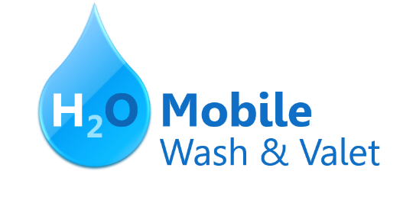

∙ H₂O Signature Wash
Cars $20 ∙ SUVs $25 and up
Hand wash and dry vehicle, including tires, rims, wheel wells, and door jambs.
Interior vacuum, dust, and deodorize, plus windows inside & out.

∙ Signature Interior
Cars $40 ∙ SUVs $60 and up ∙ March special! $5 off
Shampoo carpets, floor mats, seats, and door panels. Clean and protect console, dash, and cup holders.

∙ H₂O Signature Detail
Cars $60 ∙ SUVs $75 and up ∙ March special! $10 off
Everything included in the Signature Wash, plus hand wax and buff.

∙ Leather Cleaning & Conditioning
Cars $20 ∙ SUVs $40 and up ∙ March special! $5 off
Includes seats and door panels.

∙ Engine Cleaning
Cars $35 ∙ SUVs $45
Clean & shine engine compartment.

∙ Paint Correction & Protection
Call for pricing ∙ March special! 10% off

Prices may vary depending on size of vehicle. Heavily soiled vehicles are subject to an additional charge.
Schedule your appointment today!
Contact Hank Odum at 321-555-5400 or hank@H2Omobile.com
Special rates available for weekly/monthly customers

H₂O Mobile Wash & Valet | Just leave the details to us

H₂O Mobile’s
UNLIMITED WASH CLUB

H₂O Signature Detail Plan $84.99/mo
Includes:
Fragrance
Hand wax
Wax and buff
Hand wash and dry vehicle, including tires, rims, wheel wells, and door jambs
Interior vacuum
Dust
Deodorize
Windows Inside & Out

H₂O Signature Wash Plan $79.99/mo
Hand wash and dry vehicle, including tires, rims, wheel wells, and door jambs
Interior vacuum
Dust
Deodorize
Windows Inside & Out

For more details, contact Hank Odum at 321-555-5400 or hank@H2Omobile.com
Prices may vary depending on size of vehicle. Heavily soiled vehicles are subject to an additional charge
Just leave the details to us
H₂O Mobile Wash & Valet |

