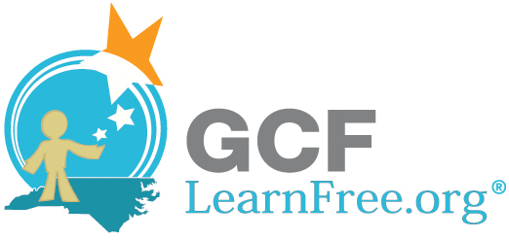Developing Your Blog
As you read lesson 3 of the Blog Basics tutorial, fill in your blogging goals and decisions below.
Identifying Your Blogging Goals
- Your primary goal:

- Your secondary goals:

Defining Your Blog’s Topic
- Main topic:

- Possible sub-topics:

- Ideas for potential blog posts:

Deciding How Much Time to Commit
- How many times do you want to post per week?

- Any special posting days or times?

Deciding How Much Personal Information to Share
- Will you use your real name? Yes / No

- If no, what name will you use?

- Will you share information about…

Where you live? Yes / No

Your job? Yes / No

Your family and friends? Yes / No

- Will you link to social media accounts like Twitter and Facebook?

Designing Your Blog
- Potential blog names:

- Blogs to use as design inspiration:

- Ideas for your blog’s appearance:

