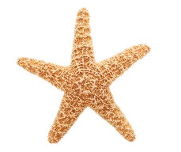



You’re invited to our 7th annual

Sunny Days Ahead

celebration

Come join the Marquez family (at our beach house) as we celebrate the arrival of summer.

Where: **Silver Shells Beach Community  
1888 Conch Circle  
La Playa Beach, FL 30204**

When: **Saturday, June 1, 2013**

Time: **3pm – 8pm**



Featuring groovy Beach Music 🎜 from 🎜  
The Phish Phinz